**Real time File Transfer (Continuous polling) and resolve issue related to 0 KB file transfer**

**XML Code for Process:**

<process name = "boxToFs_vnp_4">

<rule name="more_docs">

<condition>count(/ProcessData/Message) &gt; 0</condition>

</rule>

<sequence>

<operation name="Mailbox Query Service">

<participant name="MailboxQuery" />

<output message="MailboxQueryServiceTypeInputMessage">

<assign to="." from="*" />

<assign to="MailboxPath">/</assign>

<assign to="UseGlobalMailboxes">false</assign>

</output>

<input message="inmsg">

<assign to="." from="*" />

</input>

</operation>

<sequence name="forSequence">

<choice name="test">

<select>

<case ref="more_docs" activity="PutSeq"></case>

</select>

<sequence name="PutSeq">

<assign name="Assign" to="test" from="/ProcessData/Message[1]/MessageId/text()"></assign>

<operation name="Mailbox Extract Begin Service">

<participant name="MailboxExtractBegin"/>

<output message="MailboxExtractBeginServiceTypeInputMessage">

<assign to="CommitNow">NO</assign>

<assign to="MessageId" from="/ProcessData/Message[1]/MessageId/text()"></assign>

<assign to="." from="*"></assign>

</output>

<input message="inmsg">

<assign to="." from="*"></assign>

</input>

</operation>

<operation name="File System Adapter">

<participant name="fileSystem_VN"/>

<output message="FileSystemInputMessage">

<assign to="." from="*"></assign>

<assign to="Action">FS_EXTRACT</assign>

<assign to="extractionFolder">C:\Users\db2admin\Downloads\venkyDeript</assign>

</output>

<input message="inmsg">

<assign to="." from="*"></assign>

</input>

</operation>

<operation name="Release Service">

<participant name="ReleaseService"/>

<output message="ReleaseServiceTypeInputMessage">

<assign to="TARGET">/ProcessData/Message[position()=1]</assign>

<assign to="." from="*"/>

</output>

<input message="inmsg">

<assign to="." from="*"/>

</input>

</operation>

<repeat name="endLoop" ref="forSequence"/>

</sequence>

</choice>

</sequence>

</sequence>

</process>

Step 1:login to B2B Dashboard console.

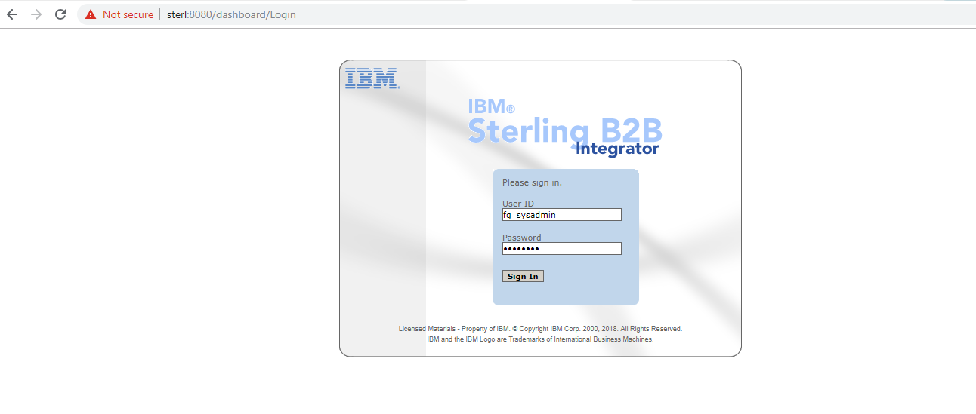

User can able to see dashboard

Step 2: Go to Administration Menu

Create a Process using above given code.

Click on Business Processes >>Manager

click on Create Process Definition Go button as shown in below Pic.

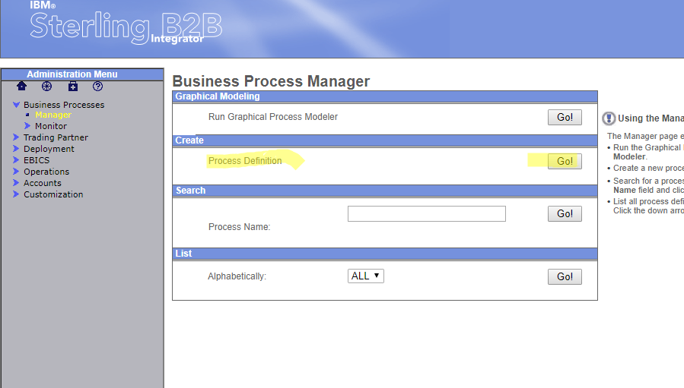

Step3: Enter Process name : boxToFs_vnp_5 and Create the Process

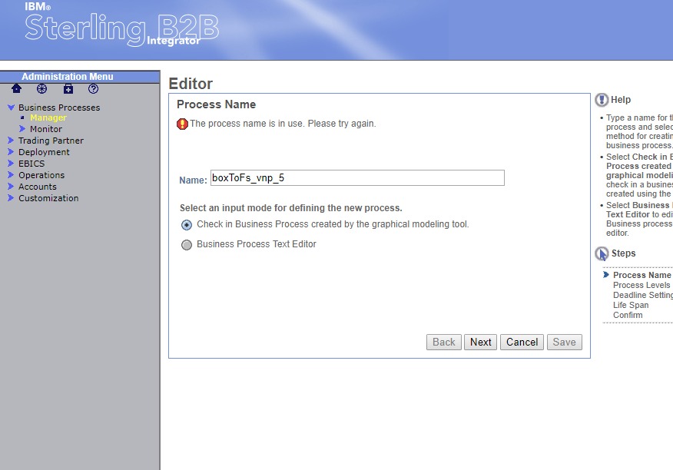

Step 4:Go to Administration Menu>> Deployment >> Schedulers

Create a new scheduler for above created new process to run automatically.

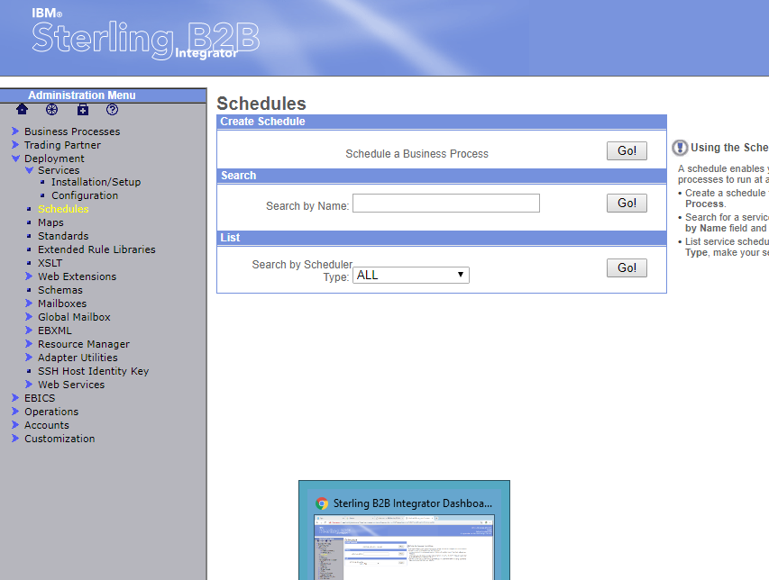

Step 5:

Select the User to as run by Process and type of scheduler is time based.

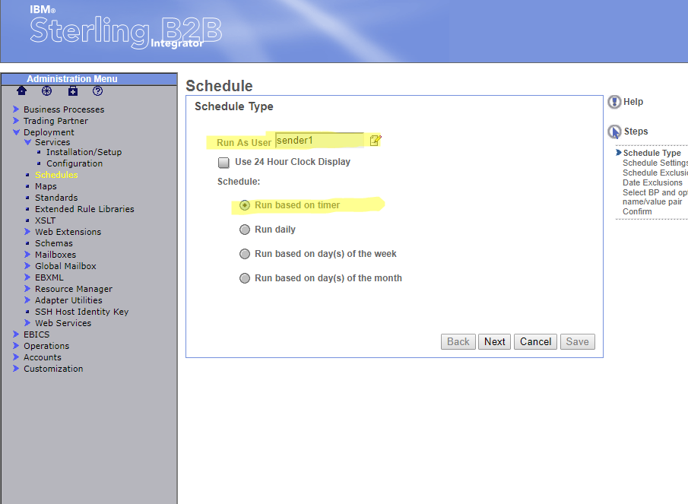

Schedule it for every 2 minutes below

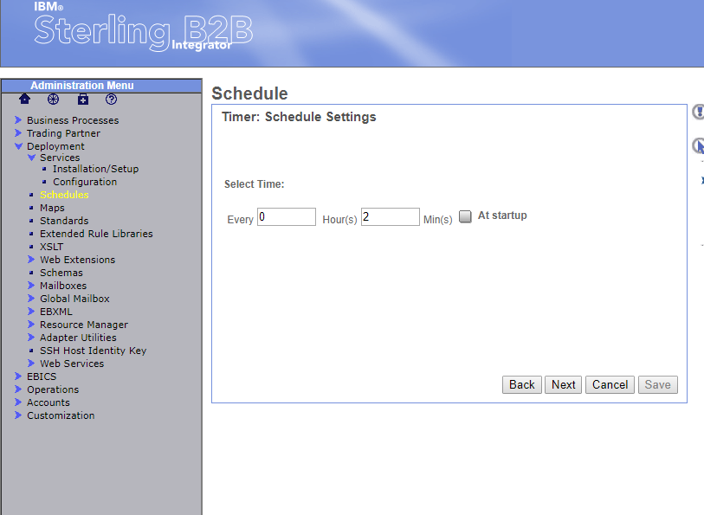

Select the Business Process Name from drop down and finish the scheduler Creation.

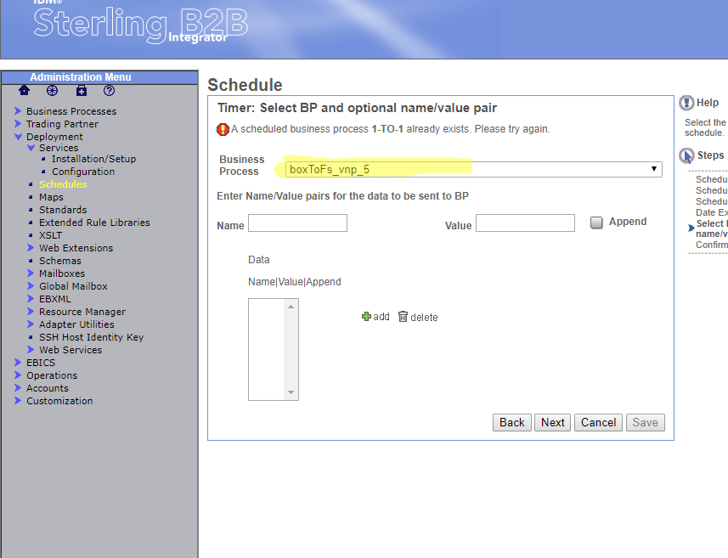

Scheduler will run automatically for every 2 minutes in frequency.

To run the Process Manually choose the user and click on Go button it will show the status of Process.

